# Abstract

The purpose of this study was to determine a range of working temperatures and pressures for a boiler and for a condenser that were viable for an organic Rankine cycle using a refrigerant or a water/glycol mixture as a working fluid and to determine possible technical obstacles to implementing such a system in an automotive application.

It was found that it would be very difficult to integrate a vapor-power cycle of this kind in the existing coolant loop. It was also found that a refrigerant such as R245fa would be appropriate for the operating temperatures and pressures that were feasible in this application. The pressure and temperature ranges for the boiler were found to be 0.5MPa – 1.0MPa and 60oC – 90oC respectively and the pressure and temperature ranges for the condenser were found to be 0.15MPa – 0.5MPa and 20oC – 60oC respectively.

Keywords: Rankine cycle, Working pressure, Working temperature, Boiler, Condenser, Power-vapor cycle.

# Feasibility

The efficiency of cycles which turn heat into work/energy is proportional to the difference in temperature between the heat source and the heat sink; low temperature differentials are difficult to utilize for energy reclamation.

When evaluating the feasibility of WHR, the heat source is characterized based on the following parameters [1]:

* Heat quantity
* Heat temperature (quality)
* Composition
* Minimum allowed temperature
* Availability and other logistics

The quantity is a measure of how much energy is contained in a waste heat stream, while quality is a measure of the usefulness of the waste heat. The quantity of waste heat contained in a waste stream is a function of both the temperature and the mass flow rate of the stream:

Equation 1:Quantity of waste heat in mass flow stream

Where Ė is the waste heat loss in Watts (Btu/hr); ṁ is the waste stream mass flow rate kg/s (lb/hr); and h(t) is the waste stream specific enthalpy Watts (Btu/lb) as a function of temperature [1].

Waste heat quality is sometimes divided by heat quality based on the temperature of the waste heat where high temperatures are easier to utilize. One such division is:

Table 1: Heat quality ranges

|  |  |
| --- | --- |
| **Quality** | **Temperature range** |
| High | 1,200 oF [649 oC] and higher |
| Medium | 450 oF [232 oC] - 1,200 oF [649 oC] |
| Low | 450 oF [232 oC] and lower |

## The Carnot Cycle

The Carnot cycle is a theoretical thermodynamic cycle proposed by Sadi Carnot in 1824. It provides an upper limit on the efficiency that any classical thermodynamic engine can achieve during the conversion of heat into work. [2]

Carnot efficiency is defined to be:

Equation 2: Carnot efficiency

Considering ambient temperature to be 25 oC [77 oF], the maximum efficiency of each of these temperature ranges are as follows:

Table 2: Max efficiency of temperature ranges

|  |  |
| --- | --- |
| **Quality** | **Temperature range** |
| High | 97.92% and higher |
| Medium | 94.4% - 97.92% |
| Low | 94.4% and lower |

In practice, the efficiency of a Rankine cycle is limited by the heat transfer rate from the heat source.

## Phase transition

The Rankine cycle makes use of phase transitions of its working fluid. This could be problematic in the cooling system of the average vehicle because anti-freeze ratios vary by region and home mechanics introduce even greater variability beyond what could be predicted by auto-manufacturers.[1]

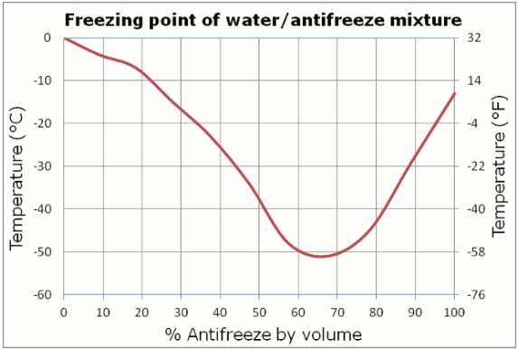

Figure : Freezing point of water/antifreeze [3]

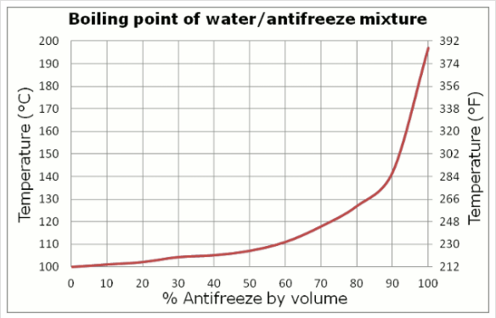

Figure : Boiling point of water/antifreeze [3]

The most common ratio is 1:1 which would result in a freezing temperature of -38oF (-39oC) and a boiling temperature of 225oF (107oC). More problematically, in colder climates, where the greater protection of a 70% antifreeze ratio might be desired, the boiling point, which is used by the Rankine cycle to drive a turbine increases to nearly 250oF (121oC).

However, assuming the mixture is nearly nominal, the boiling temperature of the fluid used in the cooling system should be near the operating temperature of the typical engine and may represent an opportunity for energy utilization.

To ensure that the phase change conditions are met, a working fluid with a boiling temperature somewhat lower than that of water should be used. This is typical in what’s called an “Organic Rankine cycle.”

## Rankine cycle

Process 1 → 2:

The working fluid goes through a pump which increases the fluid pressure.

Process 2 → 3:

The working fluid is boiled. Pressure is constant and fluid is heated by external heat source to a dry, saturated vapor.

Process 3 → 4:

The vapor expands through a turbine. Temperature and pressure are reduced in this process and some condensation may occur.

Process 1 → 2:

Vapor enters the condenser where it is condensed at a constant pressure to become a saturated liquid.

In an ideal Rankine cycle the pump and turbine would be isentropic; Process 1 → 2 and process 3 → 4.

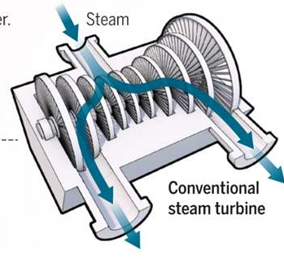

Figure 3: Conventional steam turbine

## Organic Rankine cycle

The most common working fluids for this cycle are R134a, R245fa, isobutane, pentane, propane and PFCs. In the past, CFCs and HCFCs were commonly used but are being phased out due to environmental and safety concerns. Of these fluids, R245fa appears to be the best fit, and consequently seems to be the most popular choice for low and medium grade waste heat which fits the description of this application.

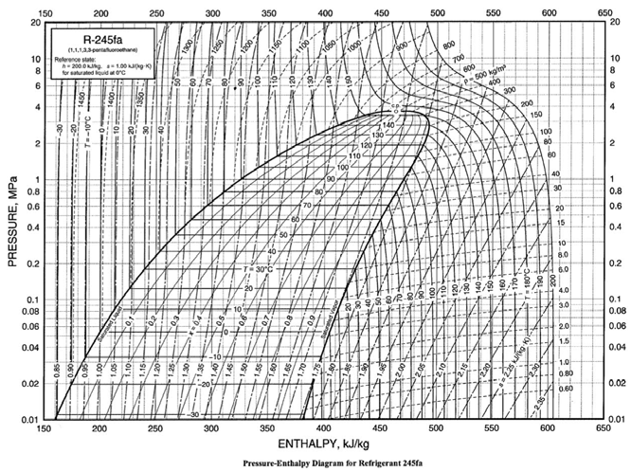

Figure 4: R245fa Pressure/Enthalpy diagram

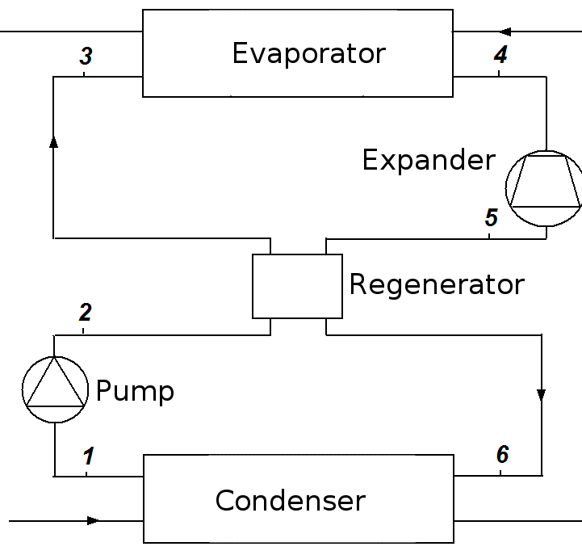

Figure : Typical ORC

The graph below shows the expected power output per unit mass flow (1kg/s). The modelled system does not include a regenerator.

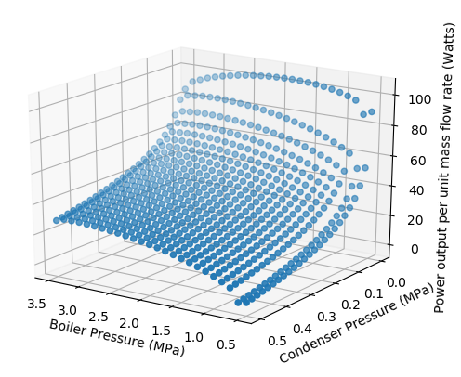

Figure 6: Theoretical power given working pressures

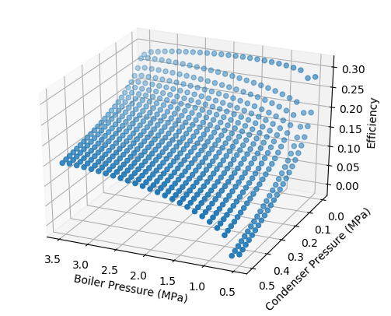

Figure 7: Turbine efficiency given working pressures

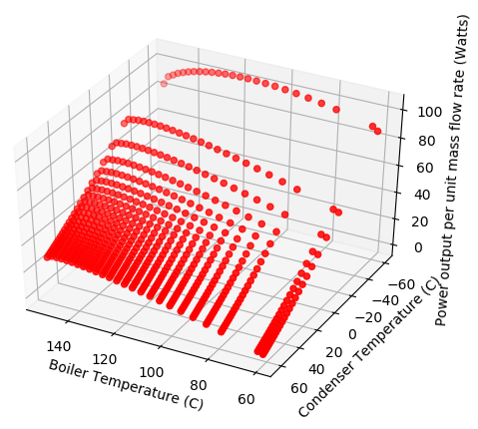

Figure 8: Power per unit mass flow given boiler and condenser temperatures

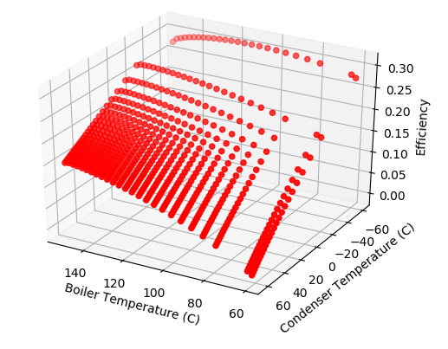

Figure 9: Efficiency given boiler and condenser temperatures

These pressures and temperatures exceed those plausible in the use case where waste heat is harvested from a cooling system in a light duty vehicle So the ranges were reduced and the resolution refined to produce a more plausible design space. In both the condenser and the boiler, the temperature constrains the problem more than the pressure does. 20C being the lowest plausible condenser pressure. And 90C being the highest plausible boiler pressure. These constraints are developed based on the difficulty of transferring heat out of the cycle below ambient temperature or transferring heat into the cycle from sub-boiling water/glycol.

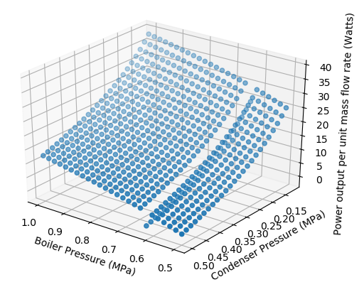

Figure 6: Theoretical power given plausible working pressures

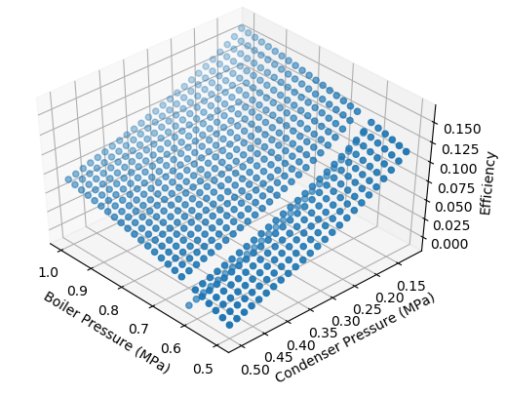

Figure 7: Turbine efficiency given plausible working pressures

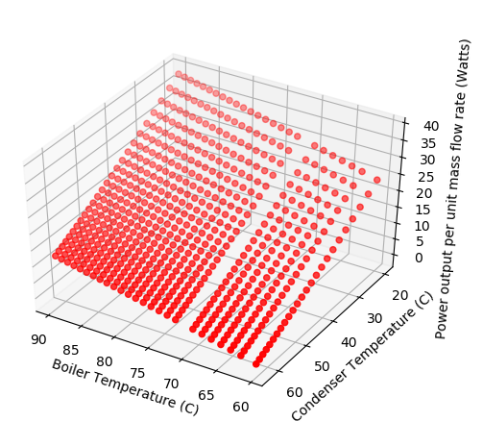

Figure 8: Power per unit mass flow given plausible boiler and condenser temperatures

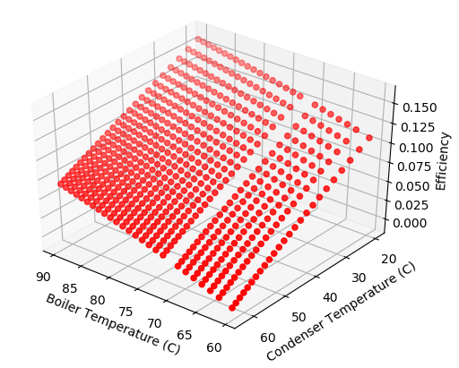

Figure 9: Efficiency given plausible boiler and condenser temperatures

## Heat transfer

Note that there is a “fouling factor” associated with refrigerants that will change the performance of the heat exchangers over time. [4] Heat transfer in the boiler and in the condenser, are also dependent on the surface area of those components. Especially as the temperature differential drops and the required transfer rate stays the same.

# Appendix A – Acronyms

ORC – Organic Rankine Cycle

WHR – Waste Heat Recovery

# Appendix B – Similar Projects

<http://nowasteproject.eu/events.php>

# Appendix C – Source Code

import csv

import math

from mpl_toolkits.mplot3d import axes3d

import matplotlib.pyplot as plt

import numpy as np

def interpolate(x1,y1,x2,y2,x):

try:

y = ((y2-y1)/(x2-x1))*(x-x1) + y1

except TypeError:

y = y1

return(y)

def vlookup(rfile, index, search_col, result_col):

# The file is where the data is stored.

# index is the item to search rows for.

# search_col is the column in which the index should be searched for.

# result_col should be the column from which the result should be extracted.

index = float(index)

search_col = int(search_col)

result_col = int(result_col)

RDR = csv.reader(rfile, dialect = 'excel')

pos_diff = 1000

neg_diff = -1000

x1 = None

y1 = None

x2 = None

y2 = None

for row in RDR:

# Search for the rows just smaller and just larger than the search

# term. Calculate the difference between the x value in a given row

# and the search term. Keep the rows that result in the smallest

# positive difference and the smallest negative difference.

try:

diff = index - float(row[search_col])

except ValueError:

if row[search_col] == "Inf":

diff = math.inf

#print("Header?")

continue

if diff < pos_diff and diff > 0:

x1 = float(row[search_col])

y1 = float(row[result_col])

pos_diff = diff

elif diff > neg_diff and diff < 0:

x2 = float(row[search_col])

y2 = float(row[result_col])

neg_diff = diff

elif diff == 0:

x1 = float(row[search_col])

y1 = float(row[result_col])

x2 = None

y2 = None

return (x1, y1, x2, y2)

# Return the x,y pairs of the search column and result column just

# above and below the desired x value.

#----------Main----------#

fig = plt.figure()

fig1 = plt.figure()

fig2 = plt.figure()

fig3 = plt.figure()

ax = fig.add_subplot(111, projection='3d')

ax1 = fig1.add_subplot(111, projection='3d')

ax2 = fig2.add_subplot(111, projection='3d')

ax3 = fig3.add_subplot(111, projection='3d')

#b_press = np.arange(30,154.01,10)

#c_press = np.arange(0.00127,30, 1)

c_press = np.linspace(0.1225, 0.5, 25)

b_press = np.linspace(0.5,1,25)

X = []

X2 = []

Y = []

Y2 = []

Z = []

Z2 = []

for xs in c_press:

for ys in b_press:

boiler_pressure = ys

condenser_pressure = xs

#print("Boiler pressure: ", boiler_pressure,"\nCondenser pressure: ",condenser_pressure)

##boiler_pressure = 1

##condenser_pressure = 0.25

temp_col = 0 # Degrees Celsius

press_col = 1 # MPa

v_col = 3 # Specific volume of vapor m3/kg

hl_col = 4 # Enthalpy of saturated liquid kJ/kg

hv_col = 5 # Enthalpy of saturated vapor kJ/kg

sl_col = 6 # Entropy of saturated liquid kJ/(kgK)

sv_col = 7 # Entropy of saturated vapor kJ/(kgK)

R245fa_db = 'R245fa Saturated properties temperature table.csv'

db_path = 'H:\\WIP\\12343 - Research & Development\\Issue #251 - Rankine cycle research\\Additional references'

# Fix states with specified pressures

p1 = boiler_pressure

p4 = boiler_pressure

file = open("%s/%s" %(db_path, R245fa_db), mode = 'r', newline='')

x1, y1, x2, y2 = vlookup(file, p1, press_col, temp_col)

boiler_temp = interpolate(x1, y1, x2, y2, p1)

file.close()

p2 = condenser_pressure

p3 = condenser_pressure

file = open("%s/%s" %(db_path, R245fa_db), mode = 'r', newline='')

x1, y1, x2, y2 = vlookup(file, p2, press_col, temp_col)

condenser_temp = interpolate(x1, y1, x2, y2, p2)

file.close()

file = open("%s/%s" %(db_path, R245fa_db), mode = 'r', newline='')

x1, y1, x2, y2 = vlookup(file, p1, press_col, hv_col)

h1 = interpolate(x1, y1, x2, y2, p1)

#print("h1 = ", h1)

file.close()

file = open("%s/%s" %(db_path, R245fa_db), mode = 'r', newline='')

x1, y1, x2, y2 = vlookup(file, p1, press_col, sv_col)

s1 = interpolate(x1, y1, x2, y2, p1)

s2 = s1

#print("s1 = ", s1,"\ns2 = ", s2)

file.close()

# Calculate the quality of state 2

# First find the liquid and vapor entropy at the condenser pressure

file = open("%s/%s" %(db_path, R245fa_db), mode = 'r', newline='')

x1, y1, x2, y2 = vlookup(file, p2, press_col, sl_col)

s2L = interpolate(x1, y1, x2, y2, p2)

file.close()

file = open("%s/%s" %(db_path, R245fa_db), mode = 'r', newline='')

x1, y1, x2, y2 = vlookup(file, p2, press_col, sv_col)

s2v = interpolate(x1, y1, x2, y2, p2)

file.close()

#print("sL = ",s2L,"\nsv = ", s2v)

try:

qual_2 = (s2 - s2L)/(s2v - s2L)

except ZeroDivisionError:

qual_2 = 0

except RuntimeWarning:

qual_2 = 0

#print("x2 = ", x2)

# Note that evaporating enthalpy is equal to the difference between the enthalpy

# of a saturated vapor and the enthalpy of a saturated liquid at a given

# temperature or pressure.

file = open("%s/%s" %(db_path, R245fa_db), mode = 'r', newline='')

x1, y1, x2, y2 = vlookup(file, p2, press_col, hl_col)

h2L = interpolate(x1, y1, x2, y2, p2)

#print("h2L = ", h2L)

file.close()

file = open("%s/%s" %(db_path, R245fa_db), mode = 'r', newline='')

x1, y1, x2, y2 = vlookup(file, p2, press_col, hv_col)

h2v = interpolate(x1, y1, x2, y2, p2)

#print("h2v = ", h2v)

hLv = h2v - h2L

#print("hLv = ", hLv)

file.close()

h2 = h2L + (qual_2*hLv)

#print("h2 = ", h2)

file = open("%s/%s" %(db_path, R245fa_db), mode = 'r', newline='')

x1, y1, x2, y2 = vlookup(file, p2, press_col, hl_col)

h3 = interpolate(x1, y1, x2, y2, p2)

file.close()

#print("h3 = ", h3)

file = open("%s/%s" %(db_path, R245fa_db), mode = 'r', newline='')

x1, y1, x2, y2 = vlookup(file, p2, press_col, v_col)

v3 = interpolate(x1, y1, x2, y2, p2)

file.close()

#print("v3 = ", v3)

h4 = h3 + v3*(p4-p3)

#print("h4 = ", h4)

W_m = h1-h2-h4+h3 # Watts of power per kg/s of mass flow rate

#print("Watts per kg/s of mass flow rate = ", W_m)

efficiency = ((h1-h2) - (h4-h3))/(h1 - h4)

X.append(boiler_pressure)

X2.append(boiler_temp)

Y.append(condenser_pressure)

Y2.append(condenser_temp)

Z.append(W_m)

Z2.append(efficiency)

ax.set_xlabel("Boiler Pressure (MPa)")

ax.set_ylabel("Condenser Pressure (MPa)")

ax.set_zlabel("Power output per unit mass flow rate (Watts)")

ax.scatter(X, Y, Z)

ax1.set_xlabel("Boiler Pressure (MPa)")

ax1.set_ylabel("Condenser Pressure (MPa)")

ax1.set_zlabel("Efficiency")

ax1.scatter(X, Y, Z2)

ax2.set_xlabel("Boiler Temperature (C)")

ax2.set_ylabel("Condenser Temperature (C)")

ax2.set_zlabel("Power output per unit mass flow rate (Watts)")

ax2.scatter(X2, Y2, Z, color='r')

ax3.set_xlabel("Boiler Temperature (C)")

ax3.set_ylabel("Condenser Temperature (C)")

ax3.set_zlabel("Efficiency")

ax3.scatter(X2, Y2, Z2, color='r')

plt.show()

# References

|  |  |
| --- | --- |
| [1] | BCS, Incorporated, "Waste Heat Recovery: - Technology and Opportunities in U.S. Industry -," 2008. |
| [2] | 15 December 2017. [Online]. Available: https://en.wikipedia.org/wiki/Carnot_cycle. |
| [3] | 28 December 2017. [Online]. Available: https://hellafunctional.com/?p=629. |
| [4] | J. P. Holman, "Heat Transfer," in *Heat Transfer*, New York, McGraw-Hill, 2010, p. 713. |

1. Harvesting waste heat from the existing coolant loop reduces the heat rejection load of the coolant system. Harvesting waste heat from the exhaust stream increases the load on the coolant system. Harvesting heat from the headers will reduce the reaction temperature in the catalytic converter. Harvesting heat after exhaust treatment results in less available thermal energy at a lower temperature. During colder months, heat rejected from the ORC condenser could be used to heat the passenger cabin. Perhaps the condenser could even replace the heater core.